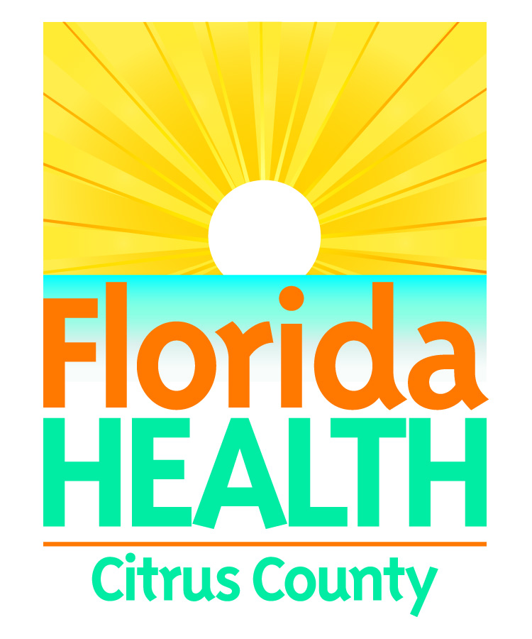

Community Health Assessment 2015
Review Comments

Following, please find my review comments:

Please provide your contact information:
Name: __________________________________________________________
Address: ________________________________________________________
Phone: _________________________________________________________
E-Mail Address: ___________________________________________________
The Florida Department of Health in Citrus County appreciates your time and input in reviewing the Community Health Assessment 2015 and Technical Appendix. If you have any questions or would like to participate in our upcoming public meetings, please contact Nancy Witty at 352-527-0068 option 1, Ext. 299 or by email at nancy.witty@flhealth.gov.

