Florida Department of Health – Citrus County Practitioner Disease Report Form
Complete the following information to notify the Florida Department of Health of a reportable disease or condition, as required by Chapter 64D-3, Florida Administrative Code (FAC). This can be filled in electronically.

SECURE FAX: 352-527-0393 PHONE: 352-527-0068 (1) Ext. 283
Mail Form To: ATTN: Communicable Disease, 3700 West Sovereign Path, Lecanto FL 34461

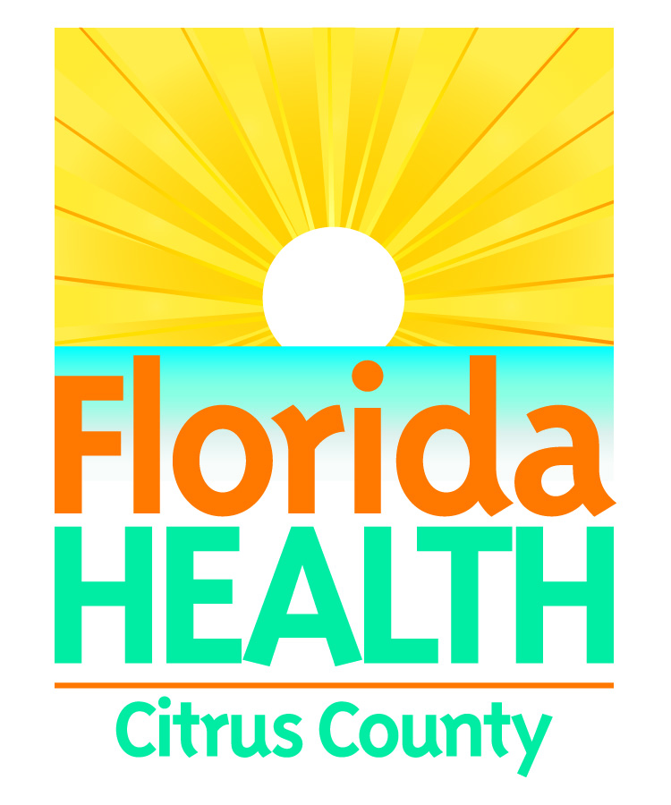

Treated: Yes No Unk
SSN:
Last name:
First name:
Middle:
Parent name:
Gender: Male
Female Unk
MRN:
City: State:
Home phone:
Other phone:
Emer. phone:
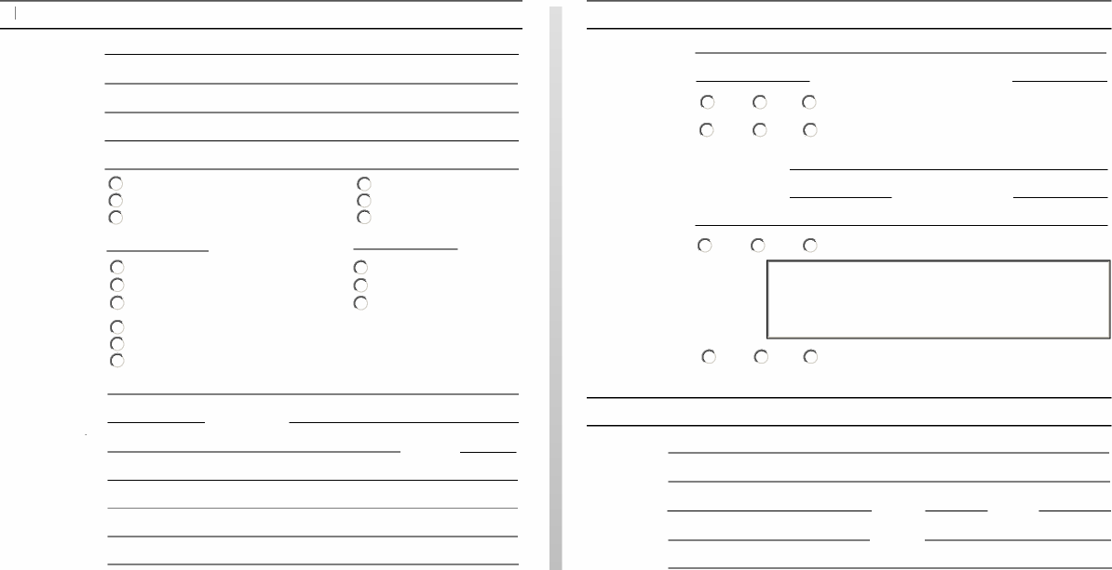
Patient Information
Birth date: Death date:
Race: American Indian/Alaska Native
Asian/Pacific Islander
Black
Ethnicity: Hispanic
Non-Hispanic Unk
Address:
ZIP: County:
White Other Unk
Pregnant: Yes
No Unk
Email:
Medical Information
Date onset: Date diagnosis:
Died: Yes No Unk
Yes No Unk
Hospital name:
Date admitted: Date discharged:
Hospitalized:
Insurance:
Specify treatment:
Provider Information
Physician: Address:
City: State: ZIP:
Phone: Fax:
Email:
Laboratory testing:
Yes No Unk Attach laboratory result(s) if available.

Reportable Diseases and Conditions in Florida Notify upon suspicion 24/7 by phone Notify upon diagnosis 24/7 by phone
HIV/AIDS and HIV-exposed newborn notification should be made using the Adult HIV/AIDS Confidential Case Report Form, CDC 50.42A (revised March 2013) for cases in people ≥1 3 years old or the Pediatric HIV/AIDS Confidential Case Report, CDC 50.42B (revised March 2003) for cases in people <13 years old. Please contact your local county health department for these forms (visit http://floridahealth.gov/chdepicontact to obtain CHD contact information). Congenital anomalies and neonatal abstinence syndrome notification occurs when these conditions are reported to the Agency for Health Care Administration in its inpatient discharge data report pursuant to Chapter 59E-7 FAC. Cancer notification should be directly to the Florida Cancer Data System (see http://fcds.med.miami.edu). All other notifications should be to the CHD where the patient resides.
To obtain CHD contact information, see http://floridahealth.gov/chdepicontact. See http://floridahealth.gov/diseasereporting for other reporting questions.
